Weather Map Research
Weather for Bellingham:
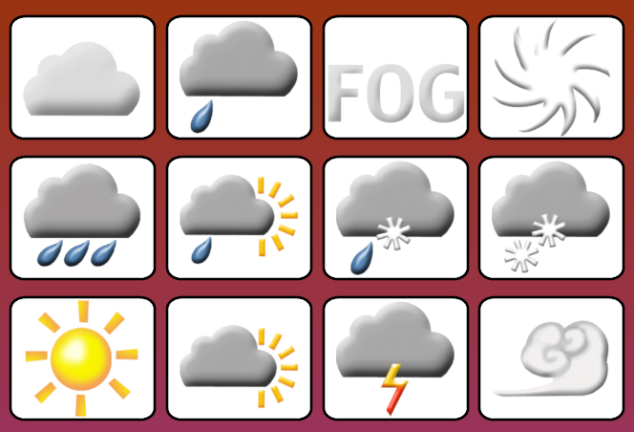
High Temperature Today:
High Temperature Tomorrow:
Weather for Seattle:
High Temperature Today:
High Temperature Tomorrow:

Weather for Spokane
High Temperature Today:
High Temperature Tomorrow:
Weather for Olympia
High Temperature Today:
High Temperature Tomorrow:

